How we grow and what we wear
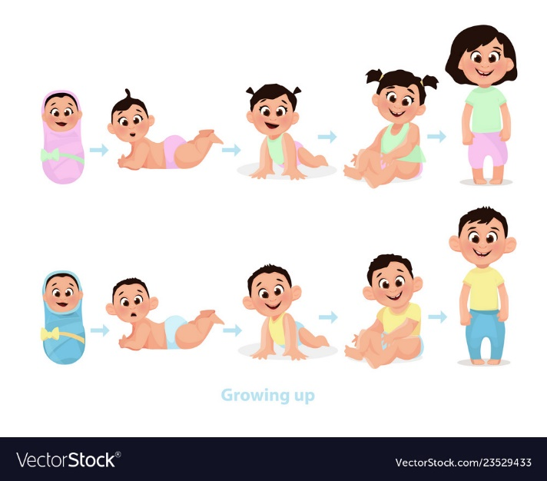
This is the way we grow
You eat carrots and you grow
I eat carrots and I grow
You eat carrots and you grow
I eat carrots and I grow
Yum yum yum yum yum!
Yum yum yum yum yum!

You eat spinach and get strong
I eat spinach and get strong
You eat spinach and get strong
I eat spinach and get strong
Yum yum yum yum yum!
Yum yum yum yum yum!

You eat nuts and you get fast
I eat nuts and I get fast
You eat nuts and you get fast
I eat nuts and I get fast
Yum yum yum yum yum!
Yum yum yum yum yum!

You eat fruit and you get smart
I eat fruit and I get smart
You eat fruit and you get smart
I eat fruit and I get smart
Yum yum yum yum yum!
Yum yum yum yum yum!

Grow (Rhyme)
I’m Small, I’m Small, I’m very, very, small
I’m all curled up in a little tiny ball.

I’m Small, I’m Small, I’m very, very, small
Then I grow, grow, grow, grrrrrrrow

I’m tall, I’m tall, I’m very, very tall
I’m taller than a fence, I’m taller than a wall.

I can grow so tall so very, very, tall
But once I was very, very, small!

If Your Happy and you know it

If you're happy and you know it, clap your hands
If you're happy and you know it, clap your hands
If you're happy and you know it, then your face will surely show it
If you're happy and you know it, clap your hands

If you're happy and you know it, stomp your feet
If you're happy and you know it, stomp your feet
If you're happy and you know it, then your face will surely show it
If you're happy and you know it, stomp your feet

If you're happy and you know it, shout "Hurray!" (Hurray!)
If you're happy and you know it, shout "Hurray!" (Hurray!)
If you're happy and you know it, then your face will surely show it
If you're happy and you know it, shout "Hurray!" (Hurray!)

If you're happy and you know it, do all three (hurray!)
If you're happy and you know it, do all three (hurray!)
If you're happy and you know it, then your face will surely show it
If you're happy and you know it, do all three (hurray!)

What is molly wearing?

Molly what are you wearing?
I am wearing socks.
Molly what are you wearing?
I am wearing socks.
Molly what are you wearing?
I am wearing socks.
Socks, Socks, Socks
She is wearing socks.

Molly what are you wearing?
I am wearing shoes.
Molly what are you wearing?
I am wearing shoes.
Molly what are you wearing?
I am wearing shoes.
Shoes, shoes, shoes.
She is wearing shoes.

Molly what are you wearing?
I am wearing a dress.
Molly what are you wearing?
I am wearing a dress.
Molly what are you wearing?
I am wearing a dress.
A dress, dress, dress
She is wearing dress.

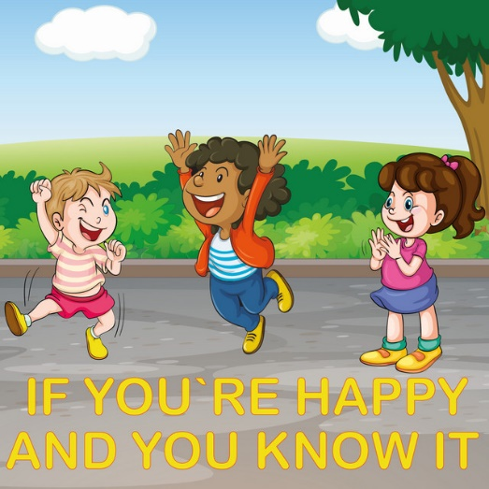

'LET'S GET DRESSED SONG LYRICS FOR KIDS'
Let’s get dressed, so we can go out and
play!
Everybody put your socks on,
your socks on
your socks on
Everybody put your socks on
Let’s do it this way
first put in one foot, then put in the other
foot
Everybody put your socks on
Let’s go out to play!
Everybody put your pants on,
your pants on
your pants on
Everybody put your pants on
Let’s do it this way
first put in one leg, then put in the other
leg
Everybody put your pants on
Let’s go out to play!
Everybody put your shirts on,
your shirts on
your shirts on
Everybody put your shirts on
Let’s do it this way
first put in one arm, then put in the other
arm
Everybody put your shirts on
Let’s go out to play!
Everybody put your shoes on,
your shoes on
your shoes on
Everybody put your shoes on
Let’s do it this way
first put in one foot, then put in the other
foot
Everybody put your shoes on
Let’s go out to play!
Everybody put your coats on,
your coats on
your coats on
Everybody put your coats on
Let’s do it this way
first put in one arm, then put in the other

Growing we do it every day

Growing - we do it every day
We're growing when we're sleeping
And even when we play
And as we grow a little older
We can do more things,
Because I'm growing and so are you.
Each day we grow a little taller,
A little bigger, not smaller.
And we grow a little friendlier too.
We try to be a little nicer
As we grow each day,
Because I'm growing and so are you.
Growing - we do it every day
We're growing when we're sleeping
And even when we play
And as we grow a little older
We can do more things,
Because I'm growing and so are you.
Each day we grow a little taller,
A little bigger, not smaller.
And we grow a little friendlier too.
We try to be a little nicer
As we grow each day,
Because I'm growing and so are you.
Because I'm growing and so are you

