Incy Wincy spider
Incy Wincy spider went up the water spout
Down came the rain and washed the spider out
Out came the sun and dried up all the rain
So, Incy Wincy spider went up the water spout again
Incy Wincy spider went up the water spout
Down came the rain and washed the spider out
Out came the sun and dried up all the rain
So, Incy Wincy spider went up the water spout again
Incy Wincy spider went up the water spout
Down came the rain and washed the spider out
Out came the sun and dried up all the rain
So, Incy Wincy spider went up the water spout again

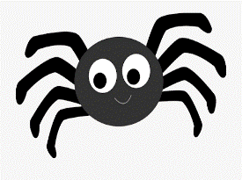

Little Miss Muffet
Little miss Muffet she sat on her tuffet, eating her curds eating and whey
Along came a spider who sat down beside her
And frightened miss Muffet away
Little miss Muffet she sat on her tuffet, eating her curds eating and whey
Along came a spider who sat down beside her
And frightened miss Muffet away
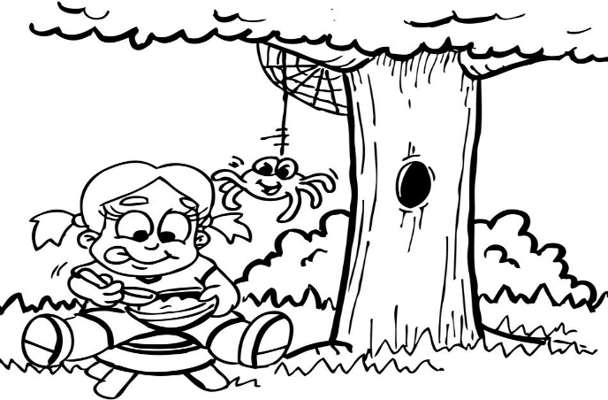
Five little speckled frogs
Five little speckled frogs sat on a speckled log
Eating some most delicious grubs (yum, yum!)
One jumped into the pool, where it was nice and cool
Now there are four green speckled frogs
Four little speckled frogs sat on a speckled log
Eating some most delicious grubs (yum, yum!)
One jumped into the pool, where it was nice and cool
Now there are three green speckled frogs
Three little speckled frogs sat on a speckled log
Eating some most delicious grubs (yum, yum!)
One jumped into the pool, where it was nice and cool
Now there are two green speckled frogs
Two little speckled frogs sat on a speckled log
Eating some most delicious grubs (yum, yum!)
One jumped into the pool, where it was nice and cool
Now there is one green speckled frog
One little speckled frog sat on a speckled log
Eating some most delicious grubs (yum, yum!)
It jumped into the pool, where it was nice and cool
Now there are no green speckled frogs

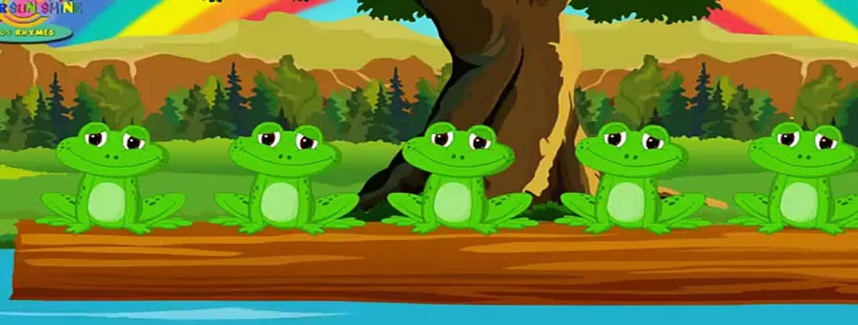

When Joey was a frog
When Joey was a frog he went
jump, jump, jump, jump, jump ,jump ,jump ,jump, jump
When Joey was a frog he went
jump, jump, jump, jump, jump ,jump ,jump ,jump, jump

When Joey was a tadpole he went
Swim, swim, swim, swim, swim, swim, swim, swim, swim
When Joey was a tadpole he went
Swim, swim, swim, swim, swim, swim, swim, swim, swim

When Joey was in frog spawn he went
Wobble, wobble, wobble, wobble, wobble, wobble, wobble, wobble, wobble
When Joey was in frog spawn he went
Wobble, wobble, wobble, wobble, wobble, wobble, wobble, wobble, wobble

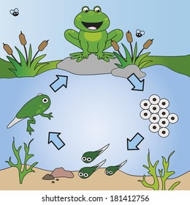
Carrying My Bumble Bee
Buzzzzzzzzz Catch!
I’m carrying my bumble bee, my bumble bee, my bumble bee
I’m carrying my bumble bee, ouch it stung me!

Squash it up,
I’m squashing up my bumble bee, my bumble bee, my bumble bee
I’m squashing up my bumble bee
Yuck my hands are all dirty

Lick it off
I’m licking of my bumble bee, my bumble bee, my bumble bee
I’m licking of my bumble bee

Oooo I have a sore tummy!
No more bumble bees for me.
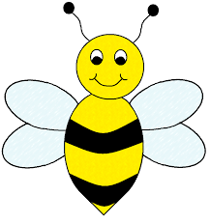

Here is the beehive
Here is the beehive
But where are all the bees?
Hiding away where nobody sees
Here they come flying out of their hive
One, two, three, four, five!
Here is the beehive
But where are all the bees?
Hiding away where nobody sees
Here they come flying out of their hive
One, two, three, four, five!
Buzz up high, buzz down low
Buzzing fast, buzzing slow
Buzz to the left, buzz to the right
Buzz all day but sleep at night
Here is the beehive
But where are all the bees?
Hiding away where nobody sees
Here they come flying out of their hive
One, two, three, four, five!

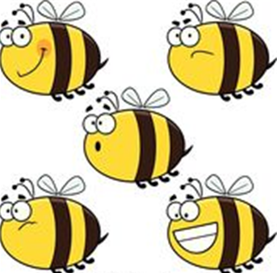

Five little butterflies
Five little butterflies resting at the door
One flew away and then there were four
Butterfly, butterfly, happy all day
Butterfly, butterfly, fly, fly away
Four little butterflies sitting in a tree
One flew away and then there were three
Butterfly, butterfly happy all day
Butterfly, butterfly fly, fly away
Three little butterflies looking at you
One flew away and then there were two
Butterfly, butterfly happy all day
Butterfly, butterfly fly, fly away
Two little butterflies sitting in the sun
One flew away and then there was one
Butterfly, butterfly happy all day
Butterfly, butterfly fly, fly away
One little butterfly left all alone
One flew away and then there were none
Butterfly, butterfly happy all day
Butterfly, butterfly fly, fly away, bye bye

