What We Grow In The Garden

The Flower
Curl up like a tiny seed
A tiny seed, a tiny seed
Warm sun is what you need
Now you can start growing
Drink the rain and start to rise
Stretch up tall, arms opened wide
Now a flower’s showing

Five Little Flower (Incy wincy spider)
Five little flowers standing in the sun
They nod their heads one by one
Down, down, down falls the gentle rain
And the five little flowers lift up their heads again

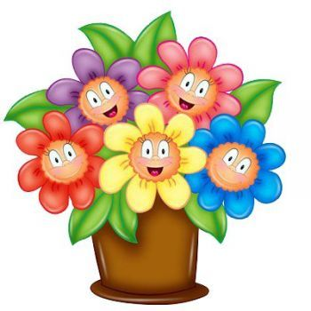
"THE FARMER PLANTS THE SEEDS SONG LYRICS'
The farmer plants the seeds,
The farmer plants the seeds
Hi, Ho, the dairy-o,
The farmer plants the seeds.
The sun comes out to shine
The sun comes out to shine
Hi- Ho the dairy-O
The sun comes out to shine
The rain begins to fall
The rain begins to fall
Hi Ho the dairy-O
The rain begins to fall
The seeds begin to grow
The seeds begin to grow
Hi Ho the dairy-O
The seeds begin to grow
The vegetables are here
The vegetables are here
Hi ho the dairy-O
The vegetables are here
The farmer digs them up
The farmer digs them up
Hi ho the dairy-O
The farmer digs them up
Now, it's time to eat
Now it's time to eat
Hi Ho the dairy-O
Now it's time to eat
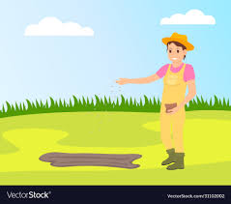

Sprinkle, sprinkle little rose (twinkle, twinkle little star)

Sprinkle, sprinkle little rose
This is how my garden grows
Just add water here and there
We'll see roses everywhere
Sprinkle, sprinkle little rose
This is how my garden grows
Tulips, daisies, bluebells too
Blooming brightly all for you
When the sun is shining down
Wonders happen on the ground
Buds of flowers start to show
Sprinkle, sprinkle and they grow
Sprinkle, sprinkle little rose
This is how my garden grows
I love you, tulips
Oh daisies, you're so pretty
I love my petunias
Sprinkle, sprinkle little rose
This is how my garden grows
Oh, what a beautiful garden
There, a little sprinkle just for you
Sprinkle, sprinkle little rose
This is how my garden grows
Day by day before your eyes
Flowers reach up to the sky
Sprinkle, sprinkle little rose
This is how my garden grows

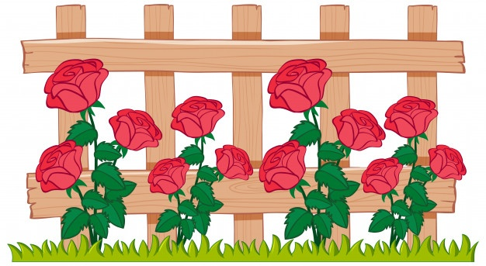

Round And Round The Garden

Round and round the garden
Like a teddy bear
One step, two step
Tickle you there!
Round and round the forest
Like a little deer
One step, two step
Tickle you there!

Mary, Mary, Quite Contrary

Mary, Mary, quite contrary
How does your garden grow?
With silver bells and cockleshells
And pretty maids all in a row
And pretty maids all in a row
Mary, Mary, quite contrary
How does your garden grow?
With silver bells and cockleshells
And pretty maids all in a row
And pretty maids all in a row
